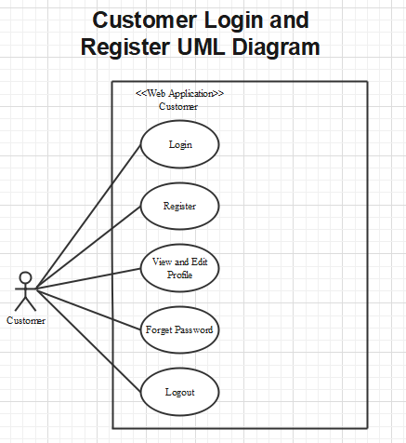

**Customer**

**Login as customer:**

|  |  |  |
| --- | --- | --- |
| **Author** |  | |
| **Use Case Name** | Login | |
| **Actors** | Customer | |
| **Description** | Customer who has registered an account can login | |
| **Requirements** | Customer provides username and password | |
| **Pre-conditions** | Customer must register an account | |
| **Post-conditions** | Success: Customer is logged in to website | |
| Fail: Refill information | |
| **Basic flow** | **Actor’s actions:** | **System’s responses:** |
| 1. Customer clicks ‘Login’ button on Home Page.  3. Actor inputs Email and Password, then click the ‘Login’ button. | 2. System redirects to Login Page with the following controls:  - “Email” text field  - “Password” text field  - “Login” button  4. System checks the information.  5. System redirects to Customer’s dashboard. |
| **Exceptions** | **Actor’s actions:** | **System’s responses:** |
| 1. Actor inputs invalid email and password. | System redirects to Login page with the following controls:  - “Email” text field  - “Password” text field  - “Login” button  System shows message: “Invalid email and password”. |

**Register as customer:**

|  |  |  |
| --- | --- | --- |
| **Author** |  | |
| **Use Case Name** | Register as Customer | |
| **Actors** | Customer | |
| **Description** | Customer who has registered an account can login | |
| **Requirements** | Customer registers an account on the website and becomes a member | |
| **Pre-conditions** | Customer provides their register information | |
| **Post-conditions** | Success: Customer creates a User account in this website | |
| Fail: Refill information | |
| **Basic flow** | **Actor’s actions:** | **System’s responses:** |
| 1. Customer clicks “Register” button on Home Page.  3. Customer inputs register’s information and click “Register” button. | 2. System redirects to Register page and displays Registration form with the following controls:  - “Username” text field  - “Password” text field  - “Confirm Password” text field  - “Email” text field  - “Phone” text field  - “Register” button  - “Reset” button  4. System validates the information.  5. System inserts the account into database  6. System show success message. |
| **Exceptions** | **Actor’s actions:** | **System’s responses:** |
| - Actor left “Username” text field blank.  - Username has already existed.  - Actor left “Password” text field blank.  - Actor left “Confirm Password” text field blank.  - Password and confirm password don’t match.  - Actor left “Email” text field blank.  - Email has already existed.  - Actor left “Phone” text field blank.  - Input phone is not numeric format or phone length is not between 8 and 14 characters.  - Actor left “Email” text field blank or input an invalid email address. | System displays message to customer:  - “Username cannot be blank”.  - “This Username has already existed”.  - “Password cannot be blank”.  - “Confirm Password cannot be blank”.  - “Confirm Password does not match password.”.  - “Email cannot be blank”.  - “This Email has already existed”.  - “Phone cannot be blank”.  - “The phone number should be numeric only and must be between 8 and 14 digits”.  - “Email is invalid”. |

**Forgot password:**

|  |  |  |
| --- | --- | --- |
| **Author** |  | |
| **Use Case Name** | Forgot password | |
| **Actors** | Customer | |
| **Description** | Customer who has forgotten password can make a request to change password | |
| **Requirements** | Customer provides email address | |
| **Pre-conditions** | Customer must be logged on | |
| **Post-conditions** | Success: Actor can change their password | |
| Fail: Refill information | |
| **Basic flow** | **Actor’s actions:** | **System’s responses:** |
| 1. Actor clicks on “Forgot Password” button.  3. Actor inputs Email and clicks “Submit”.  5. Actor inputs reset token in Password Page and click “Submit”.  7. Actor inputs new password and click “Save”. | 2. System redirects to Password Page with the following controls:  - “Email” text field  - “Submit” button  4. System checks the information and sends a reset token to user.  6. System redirects to Password form with the following controls:  - “New Password” text field  - “Confirm Password” text field  - “Save” button  8. System validates password then updates password in database.  9. System shows message: “Your password has been changed successfully”. |
| **Exceptions** | **Actor’s actions:** | **System’s responses:** |
| 1. Actor inputs an email which does not exist in database. | System shows message: “Invalid email”. |

**Edit profile:**

|  |  |  |
| --- | --- | --- |
| **Author** |  | |
| **Use Case Name** | Edit profile | |
| **Actors** | Customer | |
| **Description** | Customer who want to update their profile | |
| **Requirements** | Customer provides their personal information | |
| **Pre-conditions** | 1. Customer is logged in | |
| **Post-conditions** | Success: Actor can edit their profile | |
| Fail: Refill information | |
| **Basic flow** | **Actor’s actions:** | **System’s responses:** |
| 1. Actor clicks “Account” button on Home Page.  3. Actor inputs personal information and clicks “Submit”. | 2. System redirects to Account page and displays Account form with the following controls:  - “Fullname” text field  - “Address” text field  - “Email” text field  - “Phone” text field  - “Birthday” text field  - “Gender” text field  - “Submit” button  4. System validates password then sends to database.  5. System shows message: “Your account has been update successfully”. |
| **Exceptions** | **Actor’s actions:** | **System’s responses:** |
| 1. Actor loggin an account which does not exist in database. | System shows message: “Invalid account”. |

**Logout:**

|  |  |  |
| --- | --- | --- |
| **Author** |  | |
| **Use Case Name** | Logout | |
| **Actors** | Customer | |
| **Description** | Customer clicks on “Logout” button and their session is terminated. | |
| **Requirements** | N/A | |
| **Pre-conditions** | 1. Customer is logged in  2. Customer no longer wants to be logged in | |
| **Post-conditions** | Success: Customer can logout | |
| Fail: Refill information | |
| **Basic flow** | **Actor’s actions:** | **System’s responses:** |
| 1. Actor clicks “Log out” button on Home Page. | 2. The system logs the actor out and invalidates the session.  3. The system redirects to the default logout page. |
| **Exceptions** | **Actor’s actions:** | **System’s responses:** |
| 1. Actor can not logout | System shows message: “Not logged in”. |

**Cart**

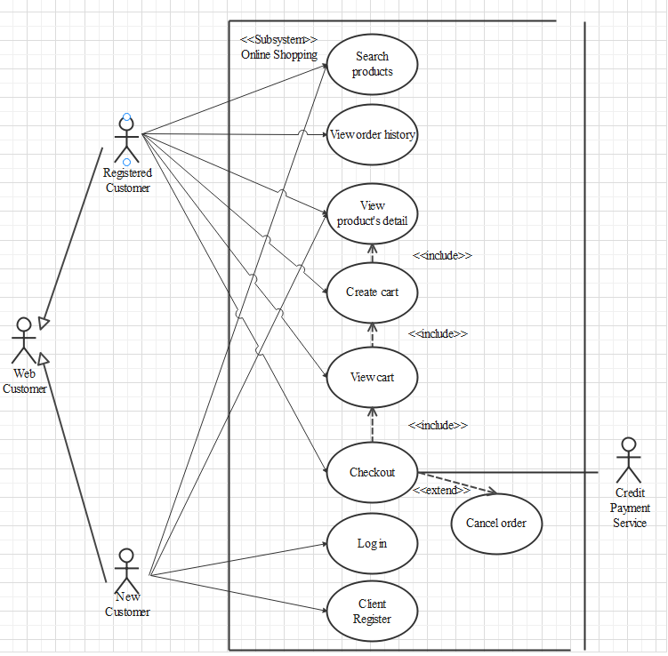

**Search products**

|  |  |  |
| --- | --- | --- |
| Author |  | |
| Use case name | Search product | |
| Actors | Guest/User | |
| Description | Guest/User can search product | |
| Requirements | Actor provides search phrase | |
| Pre-conditions | N/A | |
| Post-conditions | Success: Show product that matches search phrase | |
| Fail: No product is shown | |
| Basic flow | Actor’s actions: | System’s responses: |
| 1. Actor inputs search phrase 2. Actor clicks product’s name in list or view every product that matches search phrase. | 1. System shows list of products that match the search phrase |

**View product detail**

|  |  |  |
| --- | --- | --- |
| Author |  | |
| Use case name | View product | |
| Actors | Guest/User | |
| Description | Guest/User can view product detail | |
| Requirements | Actor select product to show product’s detail | |
| Pre-conditions | N/A | |
| Post-conditions | Success: Display product detail matching the selected product | |
| Fail: No product is shown | |
| Basic flow | Actor’s actions: | System’s responses: |
| 1. Actor select product | 1. System shows product’s detail matching selected product |

**Create cart**

|  |  |  |
| --- | --- | --- |
| Author |  | |
| Use case name | Create cart | |
| Actors | Guest/User | |
| Description | Guest/User can add product to their cart | |
| Requirements | Actor must choose at least one product | |
| Pre-conditions | Actor must log in before adding product | |
| Post-conditions | Success: Actor add product to cart successfully | |
| Fail: Refill information | |
| Basic flow | Actor’s actions: | System’s responses: |
| 1. Actor chooses a product and click “Add to cart”. | 2. System adds selected product to cart by product_id |
| Alternative flow |  |  |
| Exceptions | Actor’s action | System’s response |
|  | 1. Actor inputs more products than there are in stock. | System shows messages:   * “Product out of stock”. |

**View cart**

|  |  |  |
| --- | --- | --- |
| Author |  | |
| Use case name | View cart | |
| Actors | Guest/User | |
| Description | Guest/User can view their cart | |
| Requirements |  | |
| Pre-conditions | Actor must log in before view cart | |
| Post-conditions | Success: Actor can view their cart | |
| Fail: Refill information | |
| Basic flow | Actor’s actions: | System’s responses: |
| 1. Actor click on “Cart” icon. | 2. System shows cart and added products. |
| Alternative flow | 1. Actor clicks “Go back to shopping”  3. Actor clicks “X” button on each product. | 2. System redirects to product page.  4. System removes product from cart. |

**Checkout**

|  |  |  |
| --- | --- | --- |
| Author |  | |
| Use case name | Check out and Place order | |
| Actors | Guest/User | |
| Description | Guest/User can order products | |
| Requirements | Actor must has at least 1 cart | |
| Pre-conditions | Actor must log in before adding product | |
| Post-conditions | Success: Actor order successfully | |
| Fail: Refill information | |
| Basic flow | Actor’s actions: | System’s responses: |
| 1. Actor chooses their cart and click “Checkout” button  3. Actor clicks “Process Order” button.  5. Actor inputs order information then click “Place Order” button.  7. Actor inputs Card owner’s name, card number and security code.  10. Actor views order’s status in Order page. | 2. System shows cart and added products.  4. System shows all products in cart with calculated total price  and show following controls:   * “Billing name” text field. * “Address” text field. * “Required date” * “Payment” checkbox.   6. Systems show Payment page if user chooses Pay with Card method.  8. System validates information.  9. System redirects to Order page and show order’s status. |
| Alternative flow | 1. Actor clicks “Go back to shopping”  3. Actor clicks “X” button on each product. | 2. System redirects to product page.  4. System removes product from cart. |
| Exceptions | Actor’s action | System’s response |
|  | 1. Actor input invalid voucher code.  2. Actor inputs more products than there are in stock.  3. Actor left “Billing name” text field blank.  4. Actor left “Address” text field blank.  5. Actor left “Required date” blank.  6. Actor left “Payment” checkboxes blank.  7. Actor inputs invalid card information. | System shows messages:   * “Invalid voucher”. * “Product out of stock”. * “Billing name must not be blank”. * “Address must not be blank”. * “Must choose a required date”. * “Must choose a payment method”. * “Invalid card”. |

**Cancel order**

|  |  |  |
| --- | --- | --- |
| Author |  | |
| Use case name | Cancel order | |
| Actors | User | |
| Description | User can cancel their order | |
| Requirements | Actor provides order’s id to cancel | |
| Pre-conditions | Actor must log in to website and only can cancel when this order has not been confirmed by admin | |
| Post-conditions | Success: Cancel successfully. | |
| Fail: Order cannot cancel. | |
| Basic flow | Actor’s actions: | System’s responses: |
| 1. Actor chooses Account Tab on Menu  3. Actor chooses Order Tab on sides bar.  5. Actor selects the order which they want to cancel in Order List and clicks Cancel Button. | 2. System redirects to Account page.  4. System redirects to Order List page and displays a list of existing orders.  6. System validates inputs.  7. System change order status in the database.  8. System displays message: successful for error. |

**View order history**

|  |  |  |
| --- | --- | --- |
| Author |  | |
| Use case name | View order history | |
| Actors | User | |
| Description | User can view their order history | |
| Requirements |  | |
| Pre-conditions | Actor must log in to website | |
| Post-conditions | Success: Actor can view their order. | |
| Fail: Actor cannot see their order. | |
| Basic flow | Actor’s actions: | System’s responses: |
| 1. Actor chooses Account Tab on Menu  3. Actor chooses Order Tab on sides bar.  5. Actor selects the order that they want to view in Order List and clicks “View” Button. | 2. System redirects to Account page.  4. System redirects to Order List page and displays a list of existing orders and their status.  6. System validates inputs.  7. System displays all order’s detail and its status. |

**Admin**

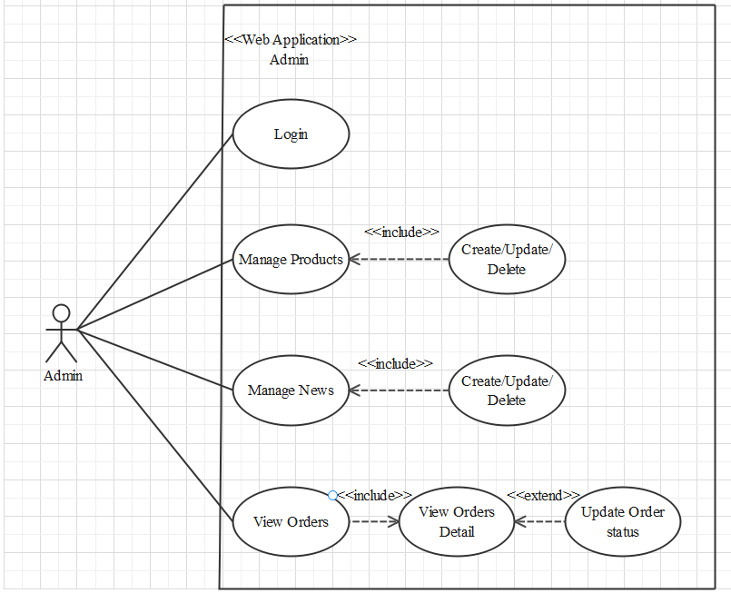

1. **Login**

|  |  |  |
| --- | --- | --- |
| **Author** |  | |
| **Use case name** | Login | |
| **Actor** | Administrator | |
| **Description** | When admin wants to manage products, news, see orders and orders detail | |
| **Requirements** | Actor provides username and password | |
| **Pre-conditions** | Actor must be exist on database | |
| **Post-conditions** | Success: Admin is logged in to website admin | |
| Fail: refill information | |
| **Basic flow** | **Actor’s actions:** | **System’s responses:** |
| 1. Actor clicks on ‘Login’ button. 3. Actor inputs Email and Password, then click the ‘Login’ button. | 2. System redirects to Login Page with the following controls  - 'Email' text field  - 'Password' text field  - 'Login' button  4. System checks the information. 5. System redirects to Admin website |
| **Exceptions** | **Actor’s actions:** | **System’s responses:** |
| 1. Actor inputs invalid email and password | System redirects to Login page with the following controls:  - ‘Email’ text field  - ‘Password’ text field  - ‘Login’ button. |

1. **Products**
2. **Create new Product**

|  |  |  |
| --- | --- | --- |
| **Author** |  | |
| **Use case name** | Create new product | |
| **Actor** | Administrator | |
| **Description** | When admin wants to create a new product | |
| **Requirements** | Actor provides product’s information | |
| **Pre-conditions** | Actor is logged in admin | |
| **Post-conditions** | Success: new product is added into the database | |
| Fail: refill information | |
| **Basic flow** | **Actor’s actions:** | **System’s responses:** |
| 1. Actor chooses Product Tab on menu.  3. Actor clicks ‘Add New Product’ button.  5. Actor inputs information to create product | 2. System redirects to ‘Product’ page and display a list of existing product.  4. System displays a form with the following fields.  - Name  - Image  - Price  - Description  - Brief  6. System validates inputs.  7. System adds product into database.  8. System displays confirmation message or error message. |

1. **Update Product**

|  |  |  |
| --- | --- | --- |
| **Author** |  | |
| **Use case name** | Update product’s detail | |
| **Actor** | Administrator | |
| **Description** | When admin wants to update product’s detail | |
| **Requirements** | Actor provides product’s information | |
| **Pre-conditions** | Actor is logged in admin | |
| **Post-conditions** | Success: product is updated in the database | |
| Fail: refill information | |
| **Basic flow** | **Actor’s actions:** | **System’s responses:** |
| 1. Actor chooses Product Tab on menu.  3. Actor clicks on ‘View Details’ on a product.    5. Actor chooses the criteria they want to update and input information. | 2. System redirects to ‘Product Details’ page and display a list of existing product.  4. System displays a form with the following fields.  - Name  - Image  - Price  - Description  - Brief  6. System validates inputs.  7. System update product into database.  8. System displays confirmation message or error message.  9. System redirects to product’s detail page. |

1. **Delete Product**

|  |  |  |
| --- | --- | --- |
| **Author** |  | |
| **Use case name** | Delete Product | |
| **Actor** | Administrator | |
| **Description** | When admin wants to delete product from the database | |
| **Requirements** | Actor provides product’s information | |
| **Pre-conditions** | Actor is logged in admin | |
| **Post-conditions** | Success: product is delete in the database | |
| Fail: product is not delete from the database | |
| **Basic flow** | **Actor’s actions:** | **System’s responses:** |
| 1. Actor chooses Product Tab on menu.  3. Actor clicks ‘Delete’ button. | 2. System redirects to ‘Product List’ page and display a list of existing product.  4. System delete product in the database  5. System displays confirmation or error. |

1. **News**
2. **Create new News**

|  |  |  |
| --- | --- | --- |
| **Author** |  | |
| **Use case name** | Create new News | |
| **Actor** | Administrator | |
| **Description** | When admin wants to create a new News | |
| **Requirements** | Actor provides New content, News | |
| **Pre-conditions** | Actor is logged in admin | |
| **Post-conditions** | Success: new content is added into the website | |
| Fail: refill | |
| **Basic flow** | **Actor’s actions:** | **System’s responses:** |
| 1. Actor chooses News Tab on menu.  3. Actor clicks ‘Add New Content button.  5. Actor inputs information to create news | 2. System redirects to ‘News’ page and display a list of News.  4. System displays a form with the following fields.  - Name  - Image  - Information  - Link  6. System validates inputs.  7. System adds News into website.  8. System displays confirmation message or error message. |

1. **Update News**

|  |  |  |
| --- | --- | --- |
| **Author** |  | |
| **Use case name** | Update News on the website | |
| **Actor** | Administrator | |
| **Description** | When admin wants to update news information | |
| **Requirements** | Actor provides News Content | |
| **Pre-conditions** | Actor is logged in admin | |
| **Post-conditions** | Success: product is updated in the website | |
| Fail: refill | |
| **Basic flow** | **Actor’s actions:** | **System’s responses:** |
| 1. Actor chooses News Tab on menu.  3. Actor clicks on ‘View Details’ on a .    5. Actor chooses the criteria they want to update and input information. | 2. System redirects to ‘News’ page and display a list of News.  4. System displays a form with the following fields.  - Name  - Image  - Information  6. System validates inputs.  7. System update News Content to website.  8. System displays confirmation message or error message.  9. System redirects to Home. |

1. **Delete News**

|  |  |  |
| --- | --- | --- |
| **Author** |  | |
| **Use case name** | Delete News | |
| **Actor** | Administrator | |
| **Description** | When admin wants to delete News from the webiste | |
| **Requirements** | Actor provides News Content | |
| **Pre-conditions** | Actor is logged in admin | |
| **Post-conditions** | Success: product is delete in the website | |
| Fail: product is not delete from the website | |
| **Basic flow** | **Actor’s actions:** | **System’s responses:** |
| 1. Actor chooses News Tab on menu.  3. Actor clicks ‘Delete’ button. | 2. System redirects to ‘News List’ page and display a list of News.  4. System delete News in the website  5. System displays confirmation or error. |

|  |  |  |
| --- | --- | --- |
| **Author** |  | |
| **Use case name** | Delete Product | |
| **Actor** | Administrator | |
| **Description** | When admin wants to delete News from the webiste | |
| **Requirements** | Actor provides News Content | |
| **Pre-conditions** | Actor is logged in admin | |
| **Post-conditions** | Success: product is delete in the website | |
| Fail: product is not delete from the website | |
| **Basic flow** | **Actor’s actions:** | **System’s responses:** |
| 1. Actor chooses News Tab on menu.  3. Actor clicks ‘Delete’ button. | 2. System redirects to ‘News List’ page and display a list of News.  4. System delete News in the website  5. System displays confirmation or error. |

1. **Order**
2. **View Order**

|  |  |  |
| --- | --- | --- |
| **Author** |  | |
| **Use case name** | View Order | |
| **Actor** | Administrator | |
| **Description** | When admin wants to know order of the product | |
| **Requirements** | Actor provides view all order have in system | |
| **Pre-conditions** | Actor is logged in admin | |
| **Post-conditions** | Success: product is show in the website | |
| Fail: Page View Order can not see from the website | |
| **Basic flow** | **Actor’s actions:** | **System’s responses:** |
| 1. Actor chooses View Order on menu.  3. Actor clicks ‘View’ button. | 2. System redirects to ‘Order List’ page and display a list of Order.  4. System show Order in the website  5. System displays confirmation or error. |

1. **View Order Detail**

|  |  |  |
| --- | --- | --- |
| **Author** |  | |
| **Use case name** | View Order Detail | |
| **Actor** | Administrator | |
| **Description** | When admin wants to see View Order Detail from the website | |
| **Requirements** | Actor provides Order Detail | |
| **Pre-conditions** | Actor is logged in admin | |
| **Post-conditions** | Success: Order Detail can be see at the website | |
| Fail: Order Detail can not see at the website | |
| **Basic flow** | **Actor’s actions:** | **System’s responses:** |
| 1. Actor chooses View Order on menu.  3. Actor clicks ‘Detail’ button. | 2. System redirects to ‘Order List’ page and display a list of Order.  4. System show Order Details in the website  5. System displays confirmation or error. |

1. **Update Order Status**

|  |  |  |
| --- | --- | --- |
| **Author** |  | |
| **Use case name** | Update Order Status | |
| **Actor** | Administrator | |
| **Description** | When admin wants to Update Order Status from the webiste | |
| **Requirements** | Actor provides Update Order Status | |
| **Pre-conditions** | Actor is logged in admin | |
| **Post-conditions** | Success: Update Order Status in the website | |
| Fail: Order Status not Update from the website | |
| **Basic flow** | **Actor’s actions:** | **System’s responses:** |
| 1. Actor chooses View Order Tab on menu.  3. Actor clicks ‘Delete’ button. | 2. System redirects to ‘Order List’ page and display a list of Order.  4. System update Order Status in the website  5. System displays confirmation or error. |

**Website Administrator**

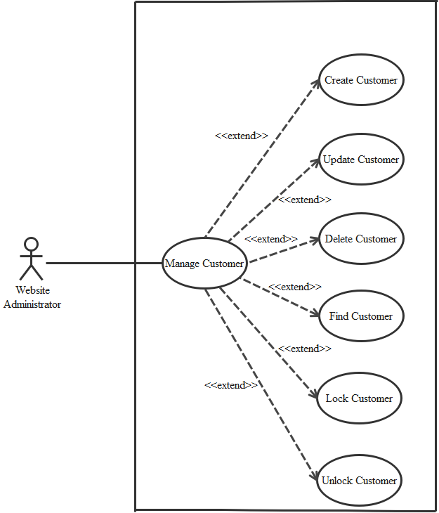

1. **Create Customer**

|  |  |  |
| --- | --- | --- |
| **Author** |  | |
| **Use case name** | Create Customer | |
| **Actor** | Admin | |
| **Description** | When admin wants to create customer | |
| **Requirements** | Actor provides customer information | |
| **Pre-conditions** | Actor is logged in admin | |
| **Post-conditions** | Success: new Customer is added into the database | |
| Fail: refill information | |
| **Basic flow** | Actor’s action | System’s responses: |
| 1. Actor chooses Customer Tab on menu.  3. Actor clicks ‘Add New Customer’ button.  5. Actor inputs information to create Customer. | 2. System redirects to ‘Customer’ page and  display a list of existing Customers.  4. System displays a form with the following fields.  ID  Fullname  Usename  Password  Adress  Phone  Email  Registered_at  Birthday  Gender  Ative  Random_key  Login_number  Expired_at  Image  6. System validates inputs.  7. System adds book into database.  8. System displays confirmation message or  error message. |

1. **Update Customer**

|  |  |  |
| --- | --- | --- |
| Author |  | |
| Use Case Name | Update Customer | |
| Actors | Admin | |
| Description | When admin wants to Update customer | |
| Requirements | Actor provides customer information | |
| Pre-conditions | Actor is logged in admin | |
| Post-condition | Success: Customer is update into the database | |
| Fail: refill information | |
| Basic flow | Actor’s action | System’s responses: |
| 1. Actor chooses Customer Tab on menu.  3. Actor clicks on ‘View Details’ on a Customer  5. Actor chooses the criteria they want to  update and input information. | 2. System redirects to ‘Custumer’ page and  display a list of existing Customers.  ID  Fullname  Usename  Password  Adress  Phone  Email  Registered_at  Birthday  Gender  Ative  Random_key  Login_number  Expired_at  Image  6. System validates inputs.  7. System adds book into database.  8. System displays confirmation message or  error message.  9. System redirects to customer’s detail page. |

1. **Delete Customer**

|  |  |  |
| --- | --- | --- |
| Author |  | |
| Use Case Name | Delete Customer | |
| Actors | Admin | |
| Description | When admin wants to delete customer | |
| Requirements | Actor provides customer information | |
| Pre-conditions | Actor is logged in admin | |
| Post-condition | Success: Customer is delete from the database | |
| Fail: Customer is not deleted from the database | |
| Basic flow | Actor’s action | System’s responses: |
| 1. Actor chooses Customer Tab on menu.  3. Actor clicks ‘Delete’ button. | 2. System redirects to ‘Customer’ page and  display a list of existing Customers.  7. System delete customer in the database.  8. System displays confirmation message or  error message. |

1. **Find Customer**

|  |  |  |
| --- | --- | --- |
| Author |  | |
| Use Case Name | Find Customer | |
| Actors | Admin | |
| Description | When admin wants to find customer by ID | |
| Requirements | Actor provides find iD | |
| Pre-conditions | Actor is logged in admin | |
| Post-condition | Success: Show customer that matches ID | |
| Fail: No customer to shown | |
| Basic flow | Actor’s action | System’s responses: |
| 1 Actor inputs find ID.  3. Actor clicks customer’s title in list or view  Every customer that matches find ID. | 2. System show list of customer that match the ID. |

1. **Lock Customer**

|  |  |  |
| --- | --- | --- |
| Author |  | |
| Use Case Name | Lock Customer | |
| Actors | Admin | |
| Description | When admin wants to lock a customer | |
| Requirements | Actor provides Customer’s information | |
| Pre-conditions | Actor is logged in admin | |
| Post-condition | Success: set customer’s status into “Lock” and updated in database | |
| Fail: No changes are made | |
| **Basic flow** | Actor’s action | System’s responses: |
| 1. Actor chooses Customer row on User list and  click “enabled” button | 2. System updates Customer’s status in database.  3. System displays confirmation message or  error message. |

1. **Unlock Customer**

|  |  |  |
| --- | --- | --- |
| Author |  | |
| Use Case Name | Unlock Customer | |
| Actors | Admin | |
| Description | When admin wants to unlock a customer | |
| Requirements | Actor provides Customer’s information | |
| Pre-conditions | Actor is logged in admin | |
| Post-condition | Success: set customer’s status into “UnLock” and updated in database | |
| Fail: No changes are made | |
| **Basic flow** | Actor’s action | System’s responses: |
| 1. Actor chooses Customer row on User list and  click “enabled” button | 2. System updates Customer’s status in database.  3. System displays confirmation message or  error message. |